Weather Ready Pacific
Operations Manual

Chapter 2
Programme Delivery
0.1 DRAFT FOR REVIEW

SCOPE – This chapter applies to WRP and Executing agencies.

Chapter 2. Programme Delivery

SCOPE – This chapter applies to WRP and Executing agencies.

Accountability
SPREP Sponsor / Approver | Director of CSI
SPREP Responsible Officer | WRP Programme Manager

Version History
Date | Version | Description | Author | Reviewer | Approver
160226 | 0.1 | Draft for Technical Committee Review | Jessica Yeung | 'Ofa Fa'anunu

Contents
Chapter 2. Programme Delivery 1
1. Programme Management Framework 3
2. Project Management Framework 10
3. Roles and Responsibilities 19
4. MHEWS Readiness Fund (Flexi-fund) 20
Annex 1 Concept Note and Appraisal Template 22
Annex 2 Concept Assessment Criteria 23
Annex 3 MERL Impact Pathway, Executing Agency Matrix and Reporting Templates 23
Annex 4 Sustainability, GESDI and ESS Guiding Questionnaires 23
Annex 5 Project Risk Register Template 23
Annex 6 Learnings, Adaptations and Change Register 23
Annex 7 ToR PMC Panel Task Team Template 23
Annex 8 Project Plan Template (to be developed) 23
Annex 9 WRP Asset Register 23
Annex 10 Asset Transfer Form 23
Annex 10 Project Exit and Transition Plan Template 23

SCOPE – This chapter applies to WRP and Executing agencies.
- Programme Management Framework

The programme delivery framework diagram below illustrates the dynamic and multi-layered process through which the WRP Programme is managed and delivered. It reflects the governance, technical, financial and operational inputs that shape the programme outputs. The sections below describe each component of the framework.

Figure 1.1 Programme Management Framework Diagram
The authorities for approval of these programme artefacts are found in Appendix 2.

1.1 Strategic, Financial and Technical Inputs
These inputs shape the scope and direction of WRP.
Strategic Input
- WRP Decadal Investment Plan: Long-term technical roadmap of investment priorities, costed for the region and approved by PMC.
- Ministerial & PMC Decisions: Strategic and operational direction and requests made by PMC and its Panels.
- Regional and National decisions, strategies and plans: These are relevant initiatives in the region such as the 2050 Strategy for the Pacific Blue Continent, Pacific Disability Strategy, UN Early Warnings for All initiative, WMO resolutions, decisions and recommendations. National Plans and National Sector plans such as Annual Plans and Strategies of the National Met Service, NDMOs, Civil Aviation, Transport and Infrastructure Departments, Energy Departments.
- Impact Pathway: The WRP Impact Pathway sets out the WRP objectives, and displays the causal links between KRAs, project inputs, activities and the results of those activities (outputs, intermediary outcomes, outcomes and impacts). The pathway notes significant assumptions and embodies the WRP principles.
- Recommendations from Donor committee: WRP Donor committee is not a decision-making body but provide valuable insights into the investment landscape and priorities in the region.
Financial Input
- Grant Funding / TA Agreements: Formal arrangements for financial and technical assistance approved by investors and funding partners with SPREP, in alignment with their priorities. These will be established frequently throughout the programme lifetime.
- Investor Pooled Fund Agreements (when established): Funding that is unearmarked for use in implementation of the WRP Programme. (See Chapter 5 – Pooled Fund)
- Investment Facility Agreements (when established): Agreements associated with investment into and disbursements from, the facility that generates returns for sustaining maintenance and operations of Pacific infrastructure.
Technical Input
- PMC Panel & MHEW TWG Recommendations: Alignment with NMHS needs and gaps in regional multi-hazard early warning systems.
- Technical Committee: Technical review of WRP activities, deliverables, methodology and approaches. These reviews act as quality control mechanisms before final approvals.
- GEDSI Advisory Group (when established): Multi-stakeholder group formed to provide technical guidance and advice to WRP activities. This may be incorporated into the Technical Committee cadence and agenda.

1.2 WRP Implementation Plan & Funded Work Plan

The key programme management artefact for Weather Ready Pacific is the Implementation Plan which details:
- Key Results Areas (KRA) and Activities (workstreams) planned over a decade, designed to achieve the intended Outputs, outcomes and ultimately the objective of WRP Programme as outlined in the MERL Impact Pathway.
- Funded Work plan is the subset of activities that has been prioritised and funded to date, for execution by WRP PMU.
- The Work Plan consists of individual actionable funded Projects that are each managed through the project management framework (see section 2).
The Implementation Plan and Funded Work Plan is managed and updated by WRP PMU 6-monthly with every Steering Committee Cycle.

1.3 Key Programme Artefacts & Tools
These are key tools at programme level supporting transparency, accountability, and continuous improvement at an inputs/outputs level:
- Operations Manual: Outlines policies and procedures WRP must follow during programme implementation and some which executing agencies must also follow. It is saved in the WRP Operations Manual folder of the shared drive.
- Learnings, Adaptation & Change Register: Capture learnings and reflections through out programme implementation. Tracks adaptation strategies adopted during the course of the programme (Refer to Chapter 6 MERL). Tracks change and modifications to implementation plan and work plan scope, budget and timelines for transparency.
- Risk and Issues Register: Documents and monitors programme risks and mitigation actions at appropriate levels. (Refer to Chapter 7 Risk and Issues Management)
- Event Calendar: Major events schedule and topics for Technical Committee Agenda mapped out in advance for visibility and planning purposes. It is saved in the WRP Programme Delivery / Implementation Plan folder of the shared drive
- WRP Programme Tracker: The current main tool as the source of truth on programme activities, funded work plan project, project status, spend, interim MERL data and other information. It is saved in the WRP Programme Delivery / Implementation Plan folder of the shared drive. This is intended to be updated monthly by the PMU.
- Programme Status Dashboard (To be developed by MERL Officer): This live dashboard provides high level status of programme, including spend to date against budget, project status under the funded work plan, staffing profile and cost, new/changes to funding). This dashboard will also feed into the Pacific Partnership Coordination Mechanism dashboard, developed by WMO and transitioned to SPREP for management and coordination of projects and programmes in the region.

Figure 1.2. Dashboard (to be developed)

1.5 Programme Management Outputs

The programme management framework outputs are:
- Project outputs – what WRP will deliver (e.g. physical infrastructure, training, policies, standards), as defined in the implementation plan and funded work plan, which is delivered through discreet projects following the Project Management Framework (Chapter 2, section 2)
- Reporting outputs – programme performance reporting of financials, indicators, outputs and outcomes from the activities following the MERL Framework in Chapter 6.

WRPs programmatic outputs are detailed within the MERL Framework - Impact Pathway.

Refer to Chapter 16 Knowledge Management for more detail how programme artefacts and outputs are stored and managed. The key repository is the WRP Shared Drive. All programme delivery related documents are stored here, under this folder structure.

Figure 1.3. Programme Delivery Folder System

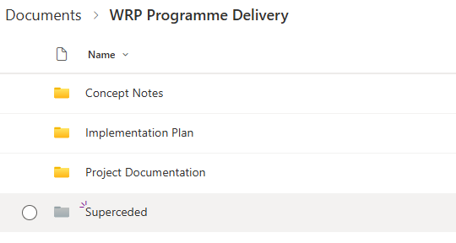

1.6 Strategic, Technical, Operational Reviews
Technical and strategic reviews is part of the routine governance process to ensure quality and relevance of the WRP Programme outputs and outcomes.
Additionally, Independent Programmatic Evaluations and Annual Partnership Health Checks are also planned at a programme level (see Chapter 6 MERL framework). For reviews at an activity/project level, see Chapter 2, section 2 Project Management Framework.

1.5.1 Strategic Review - Steering Committee Cycle
The programme is structured around the two steering committees which govern WRP. A preparation timeline is outlined below for planning purposes.
Table 1.1 Indicative Steering Committee Planning Timeline
Pre-Steering Committee Timeline | Steering Committee end April/May | Steering Committee end October/Nov
4 months prior
- Topics within papers agreed | By end of Dec | By end of June
3 months prior
- Concept Note and save the date sent  - Risk Register briefing to SPREP DG and Directors | By end Jan | By end July
2 months prior
- Executing Agency reports received | By 15 February | By 15 August
6 weeks prior
- Provisional Agenda released  - Execution freeze for PMU, no implementation which requires SC decision or endorsement  - Financial and progress/annual report drafted | By mid March | By mid September
4 weeks prior
- Updated implementation plan and work plan  - SC papers drafted | By end March | By end September
2 weeks prior
- SC papers uploaded and link circulated | By mid April | By mid October
1 week prior
- SC slide pack uploaded
- Dry run

Steering Committee | - Annual Report  - Implementation Plan & Funded Work Plan  - Partnership Health Check | - 6-month light Report  - Implementation Plan & Funded Work Plan
Post-steering committee timeline | Steering Committee end April/May |  | Steering Committee end October/Nov
2 weeks after
- Lesson and reflections session (PMU, invite other as required)  - Risk review (PMU, invite other as required) | By mid May |  | By mid November
4 weeks after
- Publish minutes to Steering committee and decisions/outcomes | By end May |  | By end November
6-8 weeks after
- Planning workshop for next 12 months (within PMU, in-person)  - Adaptation & Change Register update based on learnings and risk review  - Procurement and contracting pipeline review | By end June |  | By end December

Guiding Principles in Planning for Steering Committee
- 1 day Steering Committee minimum
- Planning meeting prior to SC to allow PMU to engage with SC and field issues
- Minimise number of separate papers, integrate them within the existing SC agenda where possible.
- Minimise the number of decisions per day of SC

1.5.2 Technical Review

The WRP Technical committee provides a high level technical review role on programme approach and delivery. It is represented by technical partners in the region and PMC panel chairs (see Chapter 1 for ToR).

For the technical committee to perform its review role effectively, topics for briefing or items requiring review can be planned in advance, so there is sufficient notice given to attend a specific technical committee meeting. The topics can be mapped in the WRP Event Calendar.

1.5.2 Operational Review

Internal PMU planning and review cycle, structured around the steering committee cycle and technical committee cycle.

Table 1.2 Operational Review Cycle
Operational Review Activity | Timing
6 monthly PMU planning and review workshop – next 12 month of activities, risk register review, adaptations and change (target 6-8 weeks after the SC meeting cycle – see table above) | By June | By Dec
6 monthly risk briefing to SPREP DG and Directors (target 3 months prior to SC meetings) | By Aug | By Feb
Monthly project status review (see table in section 2.2 Project register and Risk register to be updated monthly) – with outcomes shared via live programme status dashboard | By 15th every month
PMU Team Meeting fortnightly | Fortnightly

- Project Management Framework
The individual projects within the WRP Work Plan will follow the SPREP Project Cycle framework with additional requirements and tailoring the process for WRP projects as set out in this chapter. Refer to Project Cycle (15 August 2017).pdf for detail.
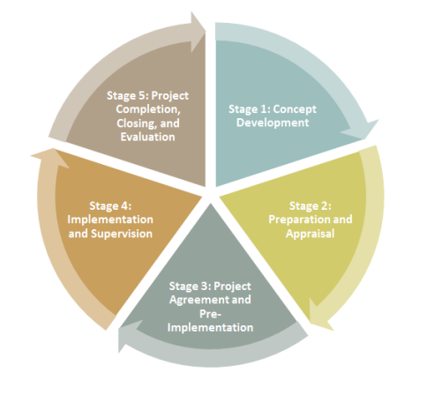
Figure 2.1: SPREP Project Cycle (version 2.0 august 2017)

In this context, the following language is used:
- Implementing Agency – refers to the agency with overall responsibility for delivery of the Project. It may sub-delegate executing activities to an Executing Agency. WRP is the implementing agency for all work where funding is flowing through WRP or work undertaken through partnership or Technical Assistance agreements.
- Executing Agency – refers to the agency that has been engaged to deliver and provide day to day management of project activities. WRP and Pacific NMHS may also be the executing agencies.

Table 2.1. WRP Project Classification Types
Standard Projects | Major Projects | External Projects | Staff
Low risk projects which are less than $300k in value, where the work carried out will use established processes and systems (e.g. BIP-M training at recognised training centres), capability or technology which is commonly sourced in the Pacific (e.g. roll out of Starlink) | Major projects can be any monetary value, and involves establishing complex infrastructure (e.g. Radars), novel technology, new approaches or systems in the Pacific (e.g. pooled fund) or involves multiple beneficiaries increasing the complexity of requirements and stakeholder engagement (e.g. AIS). These projects will require greater governance and project planning in the Project Management Framework. | Not managed by WRP PMU | Direct SPREP staff costs

Figure 2.2. WRP Project Management Framework
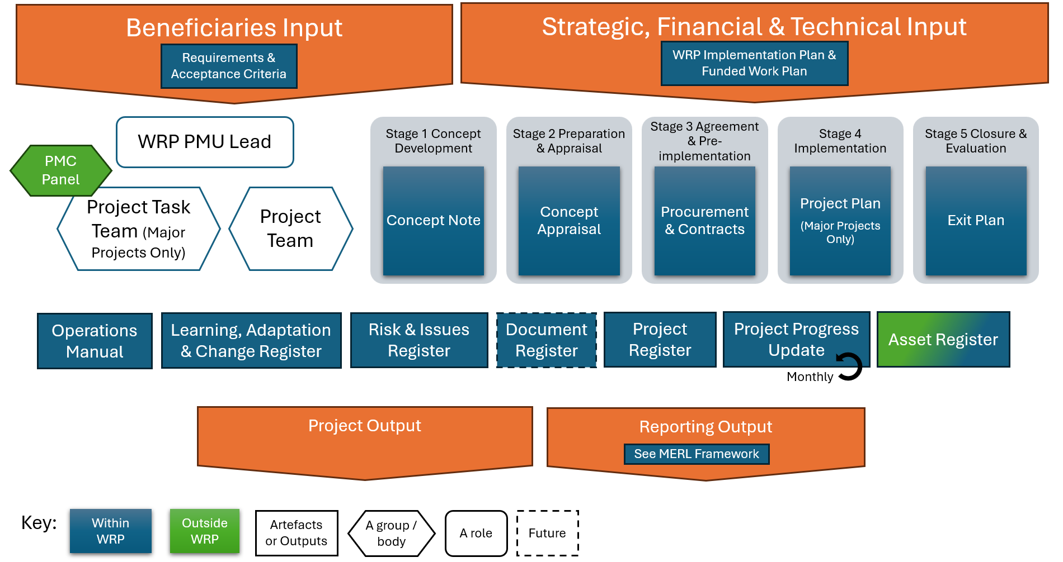

Figure 2.3. WRP & PMC Project Task Team (Major Projects Only)

2.1 Project Governance and Reviews

The key governance arrangements at project level will depend on whether it is classified as a Standard Project or a Major Project.

- Beneficiaries – the direct countries/agencies and specific staff is to be identified in concept development phase as they are a key input to define project requirements, user needs, acceptance criteria.

- PMU Lead – a WRP PMU staff who will have lead oversight of a project and the executing agency(ies), who will ensure processes are followed, report on progress are timely and accurate, review risks, actions, learnings, changes, monitor the outputs / outcomes. The PMU Lead is selected by the WRP Programme Manager based on the most aligned skillset to the Project. The PMU Lead will review and approve project deliverables and outputs (see additionally below for Major Projects).

- Project Manager – coordination point from Executing agency(ies), that develops the project plan, reporting, manage project resources, deliverables and outputs.

Additionally for Major projects:

- PMC Panel Task Team – select the relevant PMC panel under which to form a task team to be stood up for the duration of the project, to guide the project team and review and approve project deliverables and outputs. The task team will comprise of 5-8 people, consisting of technical specialists and 1-2 NMHS Director to provide strategic representation. Depending on the project, the task team members may also be involved in project execution. A template Terms of Reference for the Task Team can be found in Annex 8, to be tailored for each project by the Project Manager and approved by the PMU Lead and PMC Panel Chair. Cross-cutting specialist (GESDI, ESS, Sustainability) may be recommended to be on the Task Team, and nominated by WRP PMU Safeguard officer or GEDSI Advisory Group.

- PMC Panel(s) – which is hosting the Task Team, will have the opportunity to optionally endorse the outputs of the task team and the project at their next scheduled meeting and for the project to share the outcomes/results for broader awareness.

2.2 Project Register & Progress Update

All projects must be registered in the Project Register in order for it to appear in the WRP Funded Work Plan and propagate through to Implementation Plan and Reporting. The Project Register is found within the WRP Programme Tracker (to be replaced by a future project management software if/when implemented).

The Project Register can include work that is not yet a Project (i.e. still in Concept Development Phase). The Project Register also includes work which has funding provisionally allocated and approved by Steering Committee to deliver implementation plan activities but the Concept Note may not yet be developed.

- Concept Numbers are unique four digit numbers allocated sequentially [year,year, num, num]. For example, the first concept developed in 2025 will have a concept number “2501”.
- Project Numbers are assigned once a Concept is approved. Refer to Chapter 4 Finance on allocation of Project Numbers, Financial Phase and Task Numbers.

Regular progress updates on projects are done in the Progress Update sheet in the WRP Programme Tracker by Executing Agencies. The information captured and updated in the Project Register and Progress Update include, but is not limited to:

Table 2.2. Project Register information and Progress update frequency
Item | Frequency
Project Register
Project title | Once off
WRP Activity, Output no., KRA no. | Once off
Concept Number (live link to Concept Note) | Once off
Project Number (only if Concept is approved to be established as a project) | Once off
Financial Phase and Task number (See Chapter 4 Finance) | Once off
Project Type (Standard, Major, Staff, External) | Once off
Executing Agency | Once off
PMU Lead | Once off
Project Manager (Executing Agency) | Once off
Beneficiaries (list of countries) | Once off
Funding allocation (USD) - including any Co-funding/In-kind if relevant | As required
Funding Source/Donor if ear marked | Once off
Progress Update
Funding breakdown by calendar year and month | As required
Sustainability, GEDSI, ESS actions identified (Y/N) | 6- Monthly
MERL Table Reported (Y/N) | 6- Monthly
Actual spend by month and % spend (See Chapter 4 Finance) | Monthly
No. of risks rated significant or severe after risk response strategy | Monthly
Progress (5 stages of project cycle) | Monthly
% Progress of project | Monthly
Status (Green, Amber, Red – refer to Chapter 6 MERL) | Monthly
Status Comments | Monthly

Note: External projects are complementary projects in the pacific which WRP is not the Implementing Agency, but they contribute to the output and outcomes of WRP. External projects where PMU have identified as important to coordinate and align, may be progressively captured in the Project Register so the combined investment funding, donors, beneficiaries and outputs can be recognised. This will feed into the PPCM.

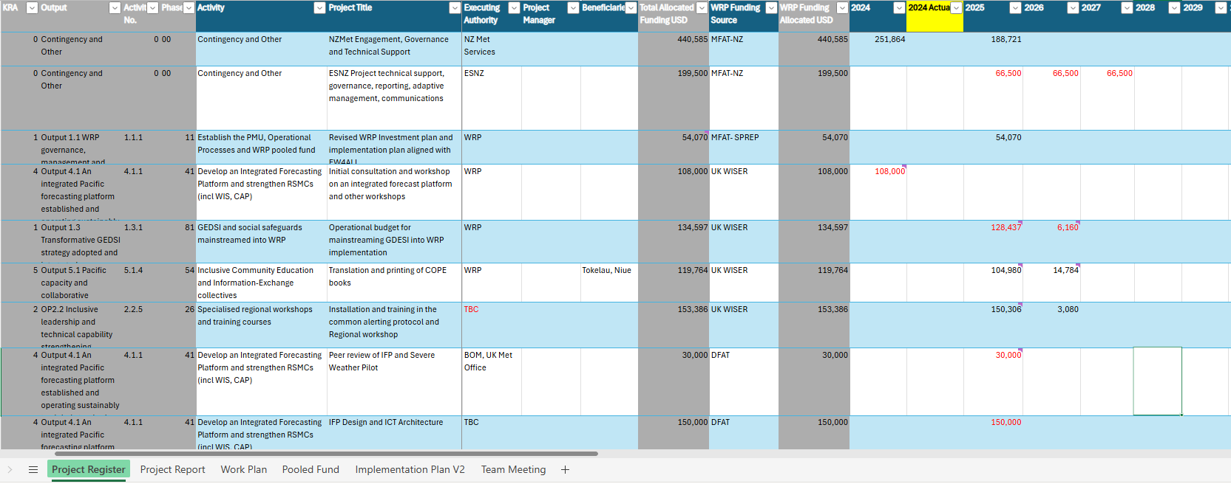
Figure 2.4. Project Register within Programme Tracker

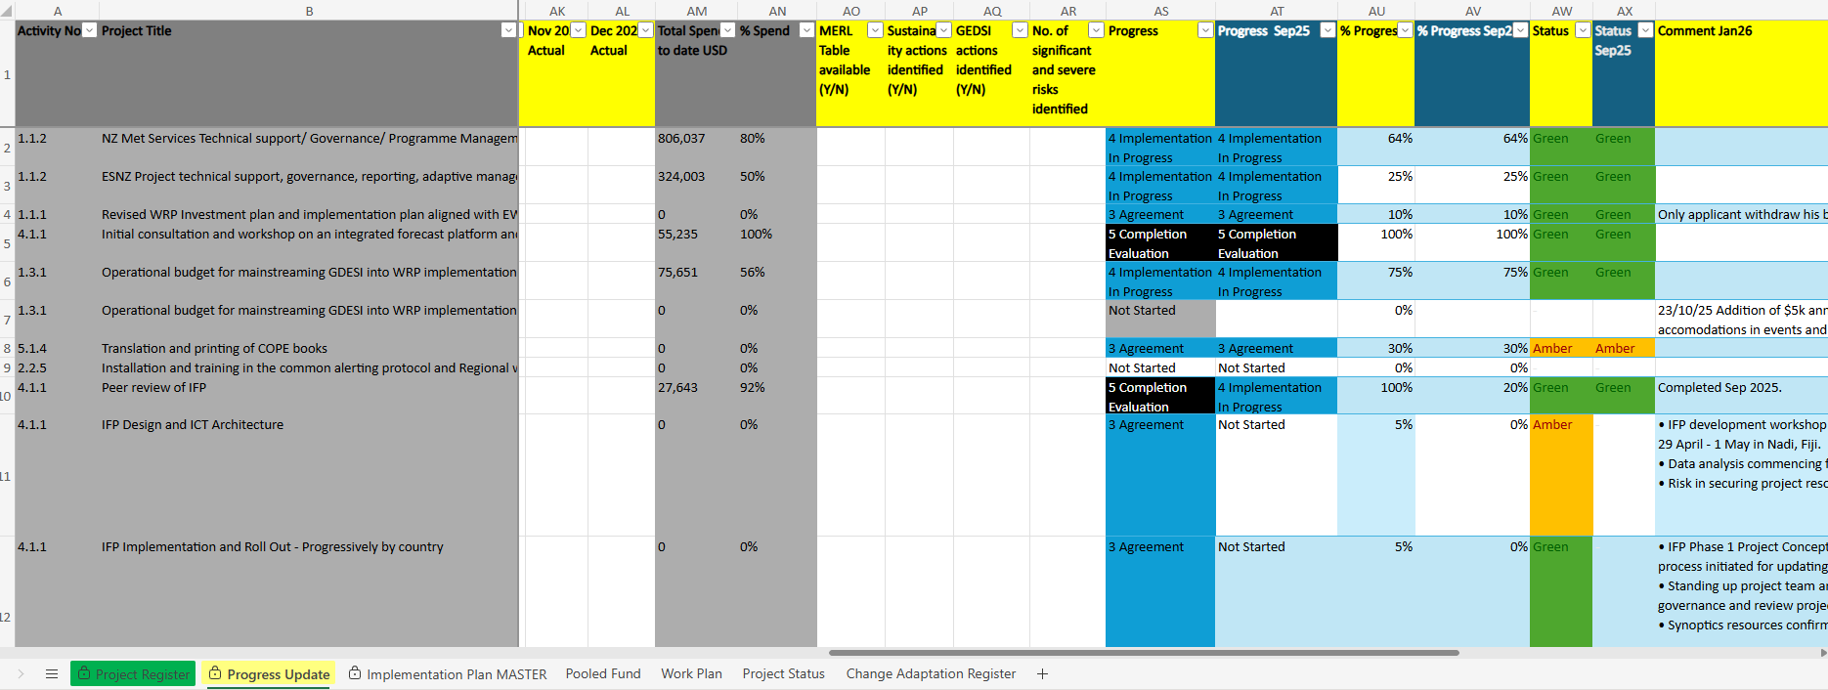
Figure 2.5. Progress Update within Programme Tracker

2.3 Project Cycle

Table 2.3 outlines how the WRP Programme applies the SPREP Project Cycle across different project types—Standard Projects, Major Projects, External Projects, and Staff-related activities. Each type has tailored artefacts, approval pathways, and reporting requirements. This ensures that all WRP projects—regardless of size or complexity—are managed with appropriate rigour and transparency, while allowing flexibility for national execution and responsiveness to emerging needs.

Where there are templates developed tailored specifically to WRP, these are provided as Annexes (and will be progressively developed as needed). Where templates are not provided (yet), denoted with *, projects can develop documentation based on their requirements.

Table 2.3 WRP Project Cycle
 | Standard Projects | Major Projects | External Projects | Staff
Stage 1 Concept Development
Artefacts | Concept Note Template (Annex 1)  Screening Questionnaires for Sustainability, GEDSI, ESS and Action Plan (Annex 3)  Project Sponsor Assigned |  | WRP reviews concept/scope | Position Description
Stage 2 Preparation & Appraisal
Artefacts | Concept Number assigned  Concept Appraisal Template (Annex 1) |  | NA | Advertising
Approver | Appraisal by PMU Lead and 2 technical committee members  +MERL Officer, ESS Officer | Appraisal by WRP Program Manager, PMU Lead and 1 technical committee member minimum.  +MERL Officer, ESS Officer | NA | WRP Program Manager
Stage 3 Agreement and Pre-implementation
Artefacts | Project Number assigned  Project Manager assigned  Refer to Chapter xx Procurement for procedures and templates for agreements / contracts. |  | NA | Interview - per SPREP Recruitment Procedures
Approver | Per SPREP Procurement Policy and Procedure |  | NA | Director HR
Stage 4 Implementation and Supervision
Artefacts | Concept Note (Annex 1), Project Plan (optional)  Project Cashflow and Gantt chart* (monthly breakdown) | Project Plan* including sections on, Requirements*, Acceptance criteria*, MERL plan, Risk Register (Annex 6), Communication and Engagement Plan*  Sustainability, GEDSI, ESS Action Plan, Project Cashflow and Gantt chart* (monthly breakdown)  PMC panel task team formed with ToR (Annex 7) | NA | Employment Contract
Reporting | 6 monthly – MERL templates (Annex 3) and monthly status (Programme Tracker) | Briefing at technical meeting  Monthly status report -Programme Tracker  6 monthly report – MERL templates (Annex 3) | PPCM | NA
Change | Change request*  Updated Concept note (Annex 1) and agreements/contracts (if required)  Record in Learning, Adaptation & Change register (Annex 7) |  | NA | NA
Approver/ Reviewer | PMU Lead | WRP Program Manager /  Task team | NA | Director HR
Stage 5 Completion, Closure and Evaluation
Artefact | Refer to MERL Evaluations, Learning & Reflections  Record in Learning, Adaptation & Change Register  Exit Plan  Asset Register / Asset Transfer |  | NA | Position filled
Reporting | Refer to Stage 4 |  | PPCM | NA

- Roles and Responsibilities
The table below is to assist in understanding the different artefacts at programme level and project level, and the responsible officer. For major projects, there is additional governance layer of review and approval by the Task Team.

Artefacts | SPREP Responsible Officer | Executing Agencies
Implementation Plan | WRP Manager
Funded Work Plan (Programme Tracker) | WRP Manager
Concept Note | WRP Manager | PM
Concept No. assignment | Pomate
Project No. assignment | Automatic (Finance Manager over-ride for Readiness Fund)
Project Plan and associated artefacts | PMU Lead *TT | PM
Terms of Reference PMC Panel Task Team | PMU Lead, PMC Panel Chair? | PM
Project Register entry (Programme Tracker) | PMU Lead
Phase and Task number assignment (SPREP Financial System) | Finance Manager
Pooled Funding update (Programme Tracker) | Finance Manager
Financial spend actual (Programme Tracker, Report) | Finance Manager | PM
Programme Report (6 monthly) | MERLA Officer
Executing Agency Report (6 monthly) | PMU Lead | Agency Lead Representative
Project Progress Update (monthly - Programme Tracker) | PMU Lead | PM
Finance Report (6 monthly) | Finance Manager | Agency Lead Representative
MERL Table (6-monthly) | MERLA Officer *TT | PM
Risk Register update – Programme | WRP Manager
Risk Register update – Project | PMU Lead *TT | PM
Sustainability, GEDSI, ESS Action Plan update – Project | PMU Lead *TT | PM
Learning, Adaptations & Change Register – Programme | WRP Manager
Learning, Adaptation & Change Register - Project | PMU Lead *TT | PM
Asset Register & Asset Transfer Form | PMU Lead | Asset Owner
Exit Plan | PMU Lead *TT | PM
Training Register | Technical Advisor Training & Capacity Development | PM
*TT - For major projects, this will be additionally reviewed by the Task Team

- MHEWS Readiness Fund (Flexi-fund)

4.1 Purpose

- Weather Ready Pacific MHEWS Readiness Fund supports small-scale national level initiatives and operational activities which align to the WRP Programme objectives, outputs and outcomes; and will be implemented in a manner consistent with the WRP principles.
- This fund empowers national agencies to be an executing agency for WRP to deliver activities and supports the development and sustained development of national MHEWS capabilities.
- This readiness fund may be utilised as an interim solution to addressing critical shortfall in operational budgets to sustain the national MHEWS services and infrastructure, and to support agencies to integrate and operationalise GEDSI, sustainability, ESS and MERL considerations within their activities.
- There will be an annual provisional budget approved by Steering Committee in the WRP work plan for the readiness fund.
- The readiness fund is not designed for large complex projects. Those should be directed to WRP as a change request to the implementation plan (and for steering committee approval if not within WRP delegations to approve).

4.2 Request Process

The WRP standard project process will be adopted for MHEW readiness fund as they are small-value and low-risk projects typically.

- Annually the WRP Steering Committee approves a provisional amount of budget for the Readiness Fund. This is not allocated against a specific WRP implementation activity.
- Requests can be made at any time by NMHS Director using the Concept Note template (Annex 1) including the supporting documentation of MERL Plan (Annex 3), Sustainability, GEDSI and ESS screening questions (Annex 4) submitted to ofaf@sprep.org
- Requestor can ask for assistance from WRP on addressing sustainability MERL, GESDI and cross cutting concerns.
- Requestor to highlight any urgency or timeline needed for getting approval.
- Requests can be committed to activities across multiple years - funds do not need to be acquitted within the same year the provisional budget is allocated.
- If WRP PMU approves the Concept Note proposal, it will then be recognised as standard project(s) in the WRP project register classified against relevant WRP Implementation Plan Activity(ies), WRP MERL Outputs and Outcomes with confirmed budget allocation.
- Letter of Agreements will be established between SPREP and the countries for Weather Ready Pacific Programme, referencing and annexes every the approved concept note, to commit the funds to countries for executing the work on deliverable basis.
- Costs will be based on the currency in which the expenditure will be incurred by the country, and an estimated USD amount identified in LOA. Currency exchange fluctuations changes will be borne by SPREP WRP.
- Funds in USD will be disbursed to the nominated account once a correctly rendered invoice is received by SPREP.
- Any interest received off the funds will be directed for the purpose they were provided for.
- Any unused funds due to activities incomplete or underspend will be returned to SPREP/WRP, unless offset by amendments or with new request.
- Approved Concept note outlines all reporting requirements, templates/portal per WRP MERL framework. This will be at a 6 monthly reporting frequency or at project completion whichever is earlier.
- Information reported may be published publicly by SPREP.
- Projects may be required to present at Steering Committee meeting.

4.3 PMU Appraisal Process
- Appraisal of requests will take place as capacity is available in the WRP PMU.
- WRP PMU Sponsor will form a panel with two technical committee representatives, and appraise the requests using assessment criteria (Annex 2) outlined in the Concept Note Appraisal template, which considers alignment with WRP outputs and outcomes, MERL plan, sustainability, GEDSI and environmental and social safeguards.
- Requests will be approved by WRP if within their delegations. If exceeding their delegations, the request will be elevated up to the next WRP Steering Committee meeting or out of session if in emergency situation.
- Any under-spend of provisional readiness fund budget each calendar year by countries, WRP will re-allocate to other activities at their discretion.
- WRP will monitor for equitable access and distribution of fund across countries, KRAs, MERL Outputs and Outcomes.
- WRP will report on distribution against the annual provisioned budget at Steering Committee meeting.
- WRP will review the effectiveness of this procedure and report to Steering Committee annually with recommended enhancements or revisions.

Annex 1 Concept Note and Appraisal Template

Annex 2 Concept Assessment Criteria

Annex 3 MERL Impact Pathway, Executing Agency Matrix and Reporting Templates
See Chapter 6

Annex 4 Sustainability, GESDI and ESS Guiding Questionnaires
See Chapter 10, Annex 10 – Sustainability Guiding Questionnaire
See Chapter 11, Annex 1 – GESDSI Guiding Questionnire

Annex 5 Project Risk Register Template

Annex 6 Learnings, Adaptations and Change Register
See Chapter 6

Annex 7 ToR PMC Panel Task Team Template

Annex 8 Project Plan Template (to be developed)

Annex 9 WRP Asset Register
See Chapter 4

Annex 10 Asset Transfer Form
See Chapter 10

Annex 10 Project Exit and Transition Plan Template
See Chapter 10

