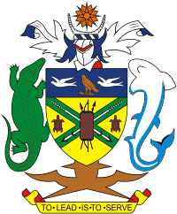

Theme: "Sustainable Weather, Climate, Ocean and Water Services for a Resilient Pacific"
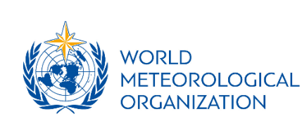
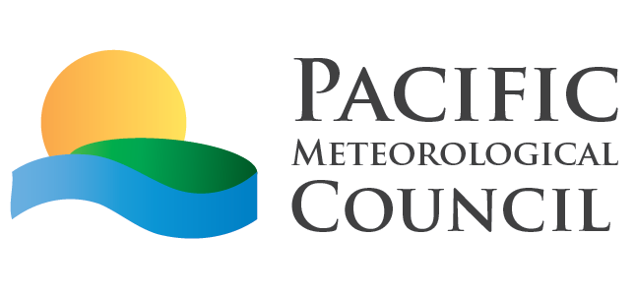
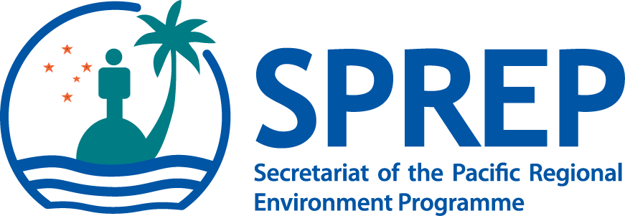

Partners and Donors Roundtable Meeting
Thursday, 17 August 2017 8:30AM-3:00PM

The first Pacific Meteorological Council’s Donors and Partners Roundtable will focus on support to weather, climate, oceans and water services in the region and will be held on Thursday, 17 August 2017 from 8:30AM to 3:00PM at the Forum Fishery Agency (FFA) Conference Facility in Honiara, Solomon Islands.

The meeting will begin with presentations to set the scene and provide an overview of the important projects underway in the region. These presentations will highlight the essential role of National Meteorological and Hydrological Services (NMHSs) to national sustainable development and the key priorities for the region as outlined in the revised Pacific Island Meteorological Strategy (PIMS) 2017-2026 and the Pacific Roadmap for Strengthened Climate Services (PRSCS) 2017-2026. They will also highlight needs and gaps in capacity, resources and funding. These presentations will be followed by interactive sessions between NMHSs and partners and donors.

Objective:
Build upon the overall objective of the PMC-4, this session will hope to;
- Provide an opportunity for NMHSs, donors and partners to discuss programs and their support for the continued development of weather and climate resilient of Pacific communities.
- Discuss strategic way forward for sustainable weather, climate, hydrology, and ocean services, in the context of the PIMS, and the PRSCS and resources mobilization during the PMC and the donors and partners roundtable meeting

Expected Outcomes:
The session will contribute to the following outcomes of the PMC-4:
- Awareness of the shared progress and issues addressed since PMC-3 and PMMM-1 and review the NMHSs priorities in the region;
- Strengthened partnership and networking between NMHSs, donors, development partners, CROP organisations, collaborating organisations and institutions;
- Increased awareness of potential direct access to financial resources accessible to the Pacific Island Countries and Territories (PICTs) for development and advancement of weather, climate, hydrology and ocean services; and
- Increase awareness of the value NMHSs and their importance in sustainable and resilient development.

The outcomes and recommendations of the Agenda 28-Donors and Partners Roundtable will be reflected in the overall PMC-4 outcomes which will be presented to the Ministerial meeting on Friday, 18 August 2017.

The Roundtable discussions are designed to be very interactive and will involve; presentations, panel and group discussions, speed dating and information sharing through the use of message boards and posters.

Detailed Agenda:

8:30-10:00 | Agenda Item | Donors and Partners Roundtable
 | 1 | Setting the Scene (5 minutes) | SPREP
 | 2 | Roles of the NMHSs and the PMC in Sustainable Development (15 Minutes) | WMO/SPREP
 | 3 | Presentation of the PIMS 2017-2026 and PRSCS 2017-2026 in the context of the needs and Priorities from the PMC-4 meeting | SPREP/WMO
 | 4 | Presentations (60 minutes): 15 minutes will be allocated to selected presentations from donors and partners (DFAT, WMO, JICA and GCF) on potential projects and opportunities for supporting the implementation of the PIMS, the PRSCS and national priorities contributing to the climate resilience of the region (60 minutes). | DFAT, WMO, JICA, GCF
10:00-10:30 |  | Refreshment
10:30-1:00 | 5  6  7 | Speed Dating: between Donors and Partners with NMHSs (60 minutes)  During the session, donors and partners will be provided designated tables and NMHSs visit briefly to discuss their priority activities. Five minutes will be allocated for each “dating” discussions and a bell (or sound) will indicate when you should move to the next “date”. Donors, Partners and NMHSs may decide to work in groups or as individuals.  NMHSs are encouraged to prepare a 1-page concept on key national priorities and donors are encouraged to prepare a 1-page information papers on areas in which they can or have supported NMHSs  Panel Discussion (60 minutes)  Topic: Climate Resilience in the Pacific  A Panel comprising of Donors, Partners and NMHSs will be selected and seated at the podium. Each will be given 5 minutes to speak on the selected topic and a moderator will be provided to facilitate questions from the participants of the meeting.  Members of the Panel:  WMO, GCF, BoM, Foreign Affairs Finland, JICA, Tonga, SPREP, SPC, Marshal Islands  Guiding topics for the Panels to speak on are;  - NMHSs and their role in supporting sustainable and resilient development  - Opportunities to support the NMHSs priorities  - What are some of the challenges in the processes for accessing funds  - Lessons learned from implementing NMHS project in the region.  - Questions and comments from the audience  Mapping Exercise (30 minutes)  Boards will be provided for each of the donors, partners and NMHSs to identify existing, and pipeline projects, and opportunities to access funds. Each participants will be provided colour coded posted notes or papers to write down their information.  The mapping will be recorded and shared with everyone as an outcome of the PMC-4.  Open Dialogue (50 minutes)  This session will focus on some of the key issues raise during the day. It will also provide an opportunity for other donors and partners and NMHSs at the meeting to share their views as well.  Closing (10 minutes): Vote of thanks from SPREP, WMO and the participants of the Donor and Partner Roundtable | ALL
2:00-3:30 |  | Lunch  Side Events  Room 1- Side Event 7: RIMES  Room 2 - Side Event 8: FINPAC-Lord Howe Community-based Early Warning System in Solomon Islands.
3:30-4:30 |  | Participants are free to make preparation for the 2nd Pacific Ministerial Meeting on Meteorology

