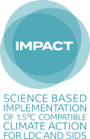
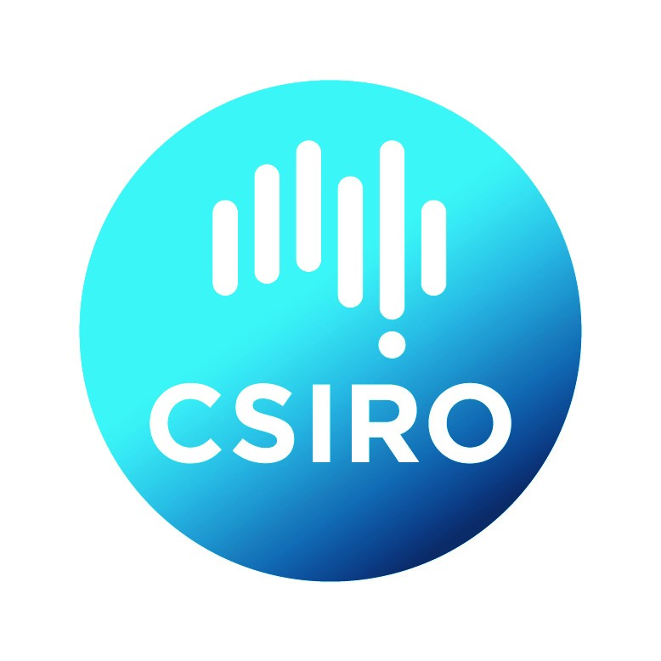
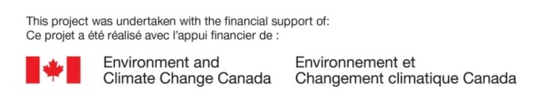
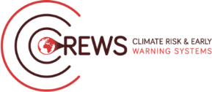
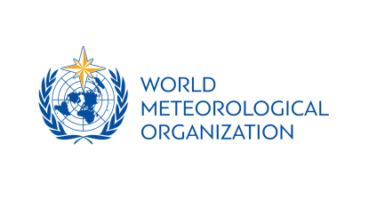

Mana Class: Reaching your audience through social media
Mana Class with SPREP with financial support from WMO, CREWS Initiative, Environment and Climate Change Canada and the Government of Samoa. Training support provided by Pacific Environment Journalists Network, Pacific Media Network and Radio New Zealand Pacific. 1.00pm – 4.15pm • 2 August 2019 • Sheraton Hotel
About this training: | Communicating information clearly and effectively to a wide audience helps enable effective preparedness for weather and climate impacts to come. Hence the role of communications for Meteorological Services across the world is crucial to the well-being and survival of many Pacific island communities and people.
Format: | 3.15 hour Mana Class
Target group: | Pacific Island Met Directors and Staff
Course goal: | This Mana class aims to support Directors and other senior personnel of Meteorological Hydrological Services in their endeavour for effective communication skills through master classes in social media and radio to be held prior to the fifth Pacific Meteorological Council.
Course outcomes: | As a result of this Mana Class, Pacific Island Met Directors and Staff will have  - Clearer understanding of the social media landscape;  - Enhanced awareness of what may go wrong and the best way to prepare for this in advance;  - Background for the development of social media plans or communication strategies; and  - Increased visibility and sharing of information through social media platforms.
Prerequisites: | To be eligible to do this course, participants will need to be:  - A Pacific Island Met Director or staff member  - Fully funded under the Pacific Meteorological Council 2019 event
Tagline: | The [Insert name here] Mana Class was held on [Insert date here] August, 2019 before the Fifth Pacific Meteorological Council to take place from 7 – 9 August, 2019 in Samoa. It is a partnership between the World Meteorological Organisation, the Climate Risk and Early Warning Systems Project, Environment and Climate Change of the Government of Canada, the Government of Samoa and the Secretariat of the Pacific Regional Environment Programme, United Nations Development Programme, IMPACT, Commonwealth Scientific and Industrial Research Organisation, and the Climate and Ocean Support Program for the Pacific. Facilitated by SPREP, this is one of three communication Mana classes conducted with training support from the Pacific Environment Journalists Network, Pacific Media Network and Radio New Zealand Pacific.
Contacts
Name | Organisation | Email | Role
Nanette Woonton | Secretariat of the Pacific Regional Environment Programme | nanettew@sprep.org | Trainer
Lisa Williams | Pacific Media Network | lisa.williams@pmn.co.nz | Trainer
Angelica Salele | Secretariat of the Pacific Regional Environment Programme | angelicas@sprep.org | Traine

Agenda
No. | Topic | Dur | Time | Facilitator | Timekeeper
1 | Registration for Mana Class  [Coffee will be available] | 15 mins | 1.00 – 1.15pm | Leanne
2 | Our social media baseline  [Interactive discussion – need a note taker] | 30 mins | 1.15pm – 1.45pm | Lisa  Angelica take notes
3 | Social media 101  [Presentation] | 30 mins | 1.45 – 2.15pm | Lisa
4 | Best way for you to work in social media  [Presentation] | 45 mins | 2.15 – 3.00pm | Nanette
5 | Graphic design tips  [Presentation] | 30 mins | 3.00 – 3.30pm | Lisa
6 | Crisis management  [What to do when things go wrong] | 30 mins | 3.30 – 4.00pm | Nanette
7 | Evaluation and wrap up | 15 mins | 4.00 – 4.15pm | Angelica

