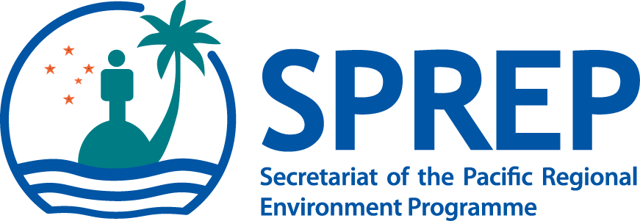

“Science to Services for a Resilient Pacific”

Fifth Meeting of the Pacific Meteorological Council (PMC-5) Working Papers

7-9 August 2019
Apia
Samoa

Agenda Item13.4: Building the capacity of Pacific Island States to respond to Extreme Weather, Water and Ocean events

Purpose:

- Scope the feasibility for a decadal program to enable the Pacific Region Small Island States to anticipate better, prepare for and respond to extreme weather events, water and ocean risks.

Background:

- The safety, security and prosperity of Pacific Region Small Island States depends upon their ability to deal effectively with weather, water, ocean and climate conditions.

- There has been significant investment in climate and climate change services capability aimed at dealing with seasonal to decadal time scales.

- There has been significant underinvestment in resources to support preparedness and response to extreme weather events at shorter timescales.

- As identified in the Pacific Islands Meteorological Strategy 2017-2026 ('the Strategy'), National Meteorological and Hydrological Services (NHMSs) support key economic and livelihood areas, including agriculture, aviation, shipping, forestry, fishing, water resource management, energy, transport and tourism. They are also crucial to enhancing resilience to natural disasters brought about by extreme weather events.

- Vulnerable infrastructure, technical and human capacity constraints are major barriers to economic security and impediments to societal resilience.

- There is also a lack of coherence and coordination in current investments resulting in incompatibility of infrastructure and technology, which can result in downstream maintenance and replacement cost challenges, that may impede collaboration between countries.

Concept/Initiative:

- An urgent decadal response is needed to enable the Pacific Region Small Island States to anticipate better and respond to extreme weather events, water and ocean risks.

- This decadal Program would seek to:

- Provide an enhanced hydro-meteorological infrastructure networks, including weather radars, automated weather and flood stations, upper air measurement, tsunami and sea level gauges, wave buoys and coastal bathymetry;
- Support and strengthen NMHSs planning, management and operating capacity;
- Build the capacity of technologists, engineers and scientists to maintain and utilise the infrastructure and the data and products from it, and;
- Strengthen regional severe weather forecasting and community decision support capabilities.
- Support Disaster management offices to better prepare, respond and recover from impacts of extreme weather events and coastal hazards impacts.

- Each Pacific country's existing capacity and future needs differ greatly.

- A comprehensive scoping study and risk analysis is required to:

- Identify priority investments that are economically sound;
- Consider the capacity to implement and sustain capability;
- Ensure alignment with existing and proposed programs;

- Having a weather-ready Pacific Region Small Island States that will deliver significant economic, safety and security benefits to the region.

- Effective weather services improve the resilience of the region against risks of weather and climate related natural disasters and can further improve the quality of critical decisions made in sectors sensitive to the extreme weather events, climate, water and oceans (agriculture, energy, tourism, fisheries etc)

- Increasing the number and reliability of data points collected enables a more accurate weather and climate reporting, and forecasts;

- Empowering NMHSs to engage credibly with stakeholders contributes to more informed local and regional decision making;

- Enhancing capability builds a stronger platform for the region to manage the impact of climate change and therefore, equipping countries with valuable information to inform adaptation and resilience strategies.

Recommendations:

The Meeting is invited to:

- Note the importance of ensuring information to support preparedness and response to extreme weather events, water and ocean risks.

- Note the need for long-term strategic investment in capability that supports critical gaps in preparedness and response at short time scales.

- Agree to commission through SPREP to undertake a study to scope a decadal Pacific regional extreme weather, water and ocean response program initiative.

- Agree to use the outcomes of the scoping study to inform deliberations at the next PMC Ministerial Meeting in 2020.

